Introduction

For this project we have split it into 5 sections and we use have used time analysis and resource analysis in this project. For analysis of the project and to see if the project will be completed within the given time set by the managers we have used CPM (Critical Path Method) and PERT (programme evaluation and Review Technique) to work this out. Additionally PCwPC has been used in the project to determine the shortest project completion time, we have also used the results of the project and produced diagrams for resource analysis. To help make a decision on a given solution we will use the skills and understanding we learn during our course time.

Requirement A

We have started with producing a network diagram to help us determine the minimum project completion time. (Appendix 1.1 on page 6) The activity-on-arrow represents the flow activities, the arrows show the activities, whereas the nodes show the number of events. Looking at the diagram we can see that the minimum time required to complete the project is 28 hours

Firstly we shall calculate the critical path analysing appendix 1, to determine the critical path we start by looking at the earliest and latest start time of the project. To determine the earliest and latest start time we use forward pass, the earliest completion time equates to the earliest start time plus the duration of the project. The earliest start time of the next activity relies on the earliest finish time of that activity. To work out the possible latest start time and latest finish time we use a backward pass, starting with the last node and taking away the duration of the project. The critical path is marked on appendix 1 and we have produced a Gantt chart (appendix 1.1a on 7) showing the critical path time period of 28 hours.

Critical Path: A, D,G,J,N,P

Secondly from the data given we can calculate the activity float (outcome is represented in appendix 1.2).The activity float helps measure the inherent surplus time of an activity’s development (reference). The activity float shows us the number of working days which can be delayed without effecting how long the project will take to complete, the activity float equates to the latest start time minus the earliest start time. Additionally we have to be aware that the float value on the critical path is zero therefore the activities have no leeway on not being completed on time, so must be completed on time otherwise this can affect the completion date of the project. The free float non-critical activities are shown in appendix 1.2

Finally we entered our data into PCwPC computer program to help us determine the shortest estimated completion time and whether the project's completion time will meet the needs of the manager. The completion time for the project is 30 hours as seen in appendix 1.4. The PCwPC helps produce a range of methods where the different heuristic priority rules applied. For the resource levelling which includes parallel and serial processes, both processes enclose preference and resource constraints. After entering our data in to PCwPC, we can see that in Appendix 1.3 the shortest project completion time is the Resource Scheduling Method, which totals 30 hours. From looking at the results we decided to produce a Gantt chart which took into consideration the 30 hours completion time (appendix 1.9 on page 12). The smoothed resource profile is also provided on the basis of the results from Gantt chart. (Please see Appendix 1.6, 1.7, 1.8 &1.9 on pages 8&9)

Requirement B

For Requirement B we are asked to produce a staff requirement profile. The Staff requirement profile shall be produced through the use of critical path, due to the fact that when using critical path you cannot change the date of the project, meaning that it is hard to maintain resource limits and time limits at the same time, therefore the resources for our staff profiles we provide have no resource constraints. To calculate the total resource requirements per day we look at the daily requirements. Once the resource requirements have been applied to the early start Gantt charts, the daily resource requirements are totalled by going through the Gantt chart day by day giving the total resource requirement per day (Reference).

From appendices 1.7 & 1.8 we can see that the maximum resource requirement is 8 men per hour, but the manager is only able to get 4 men at any given time, this shows that the resources available do not meet daily resource requirements. On appendix 2.1 (page 11) we have our resource loading diagram on the basis of earliest start time and latest start time, this shows us the requirements of resource type 1 stage by stage in more detail helping to make better decisions on scheduling methods. The resource loading start shows us that the maximum limit to resource per hour is 6 men, which also means the resources available do not fulfil the resource requirement.

Our resource cumulative curve (appendix 2.2 on page 12 ) was produced by using our cumulative staff requirements, the curve helps us create a schedule for both before and during the project (reference). The resource cumulative curve additionally shows us the demand of a resource and its progress. On our the graph we can see that the Y-axis shows the cumulative resource of the project and the X-axis shows accumulation of staff requirement throughout the time, the graph provides results both for EST and LST. After the start of the project, the level of cumulative resources required lies between the EST and LST cumulative curve but if it is out of place , this can mean that they are behind schedule or they underestimated the project. Finally from the cumulative curve we can see that it is required in initial resource allocation, it helps show the average daily requirements for resource type 1, daily requirements are found by:

Daily requirement = Total Units/ Days

110 / 28= Unit / Hours

The unit of time should be days in this case.

Requirement C

Within part c we have tried to limit the amount of resources available during specified time. By using PCWPC we premeditated the hours needed and using resources efficiently and effectively. The most efficient and effective resource time is 36 hours and quickest operational time 36 hours. Appendix 3.1 shows the Gantt chart for the shortest project duration time period of 36 hours as a result of resource scheduling. The project needs 2 workers in each task alongside another 2 available only during the morning and afternoon shifts, task of using the hoist requires either 1 or 0 depending on the activity (Appendix 3.3 on page 14). The maintenance workers have their shifts split into 3 and each shift is subject of 8 hours. The requirement shows 4 workers can be hired for early and late shifts however in the late shifts only 2 people are available. As a result of the circumstances for part C the resource method we used is parallel scheduling and the required amount of time is 36 hours. Serial and parallel are the two techniques used for resource scheduling. The parallel technique is shorter than serial method as it allows tasks to be conducted at the same given time whereas serial does not give that option. As a result some tasks are planned signally using the parallel technique.

The Gantt chart shows the tasks at 36 hours (Appendix 3.1) and shows the layout of the project structure. This is beneficial for the project management as it gives a clear overview of the tasks and schedules (reference). (Appendix 3.2) shows a graphical chart which enhances the resources needed to conduct the tasks at each time. The Gantt chart shows type 1 resources and shows time periods where there is limited amount of staff for e.g. 13 hours – 24 hours/ 31 hours – 36 hours, 2 workers at that given time. In other scenario times there can be 4 workers available, resource type 2 has 8 activities however each task needs a Crane. (Appendix 3.3) shows the amount required and hours needed for the 8 tasks. It is vital that the hoist is not required by all of the critical activities, which gives a room in time for non-critical activities to be shifted to not exceed the maximum resource availability. To find the project end time we used parallel methods and from that we see 36 hours are needed to meet the objective of completion this includes using resource method 1 which includes the critical paths and tasks.

Requirement D

The time period could be shortened from 3 down to 2 days if extra maintenance workers are assigned to task A as this activity is the beginning of the project and has no tasks beforehand henceforth the time period of the activity be shortened by adding in extra workers for maintenance. As a result the project duration time can be reduced by 1 hour. To conduct this theory we have input the figures in PCWPC from requirement A and it shows the results obtained show that the project could be completed within 29 hours which enables the project to be completed by less than 5% more of original time expected by the management. Appendix 4.4 produces a Gantt chart to confirm the finding.

Requirement E

(What is an arrow diagram, network reference?). Our arrow diagram (Appendix 1.1) shows the requirements needed; and 28 hours are needed for building times which is the shortest completion time for the project (Refer to Appendix). The resource requirements created will depend on the outcome of the schedules and the efficiency. (Appendix 1.3) Shows resource levelling for the intended project, this shows two alternative types of methods which was mentioned earlier parallel and serial. The parallel method shows alternative tasks that can be conducted at the same time (reference), consequently the minimum amount of hours needed is 29 hours, this results in limited resources used for maximise outputs. The principle proposed schedule allows a fair quality alongside the quickest time to finish the critical tasks with limited resources used. This shows that we are able to increase the time by 1 hour to 29 hours. Ultimately the schedule for building purposes allows a clear project outline which allows a clear understanding for the resources e.g. usage. In this case time is of the essence as more time is required to conduct and complete the tasks. The quality will be affected by time management and the proposed schedules, nevertheless time is often compromised when conducting tasks as the jobs are often conducted quickly as management require the task to be completed at the shortest time possible

Conclusion

The method we have chosen is parallel for this given project. From the data gathered the project will be difficult to accomplish based on the time and resource provided by the current management team. However the two clear restrictions on this project is the financial cost for workers in the maintenance department as data shows the maintenance workers are paid until the project completion time so finances are wasted in this area. Also the analysis conducted is predominantly based upon ideal situation, on a realistic outlook unpredictable, inevitable and migrating circumstances may drastically affect the project completion time which are not mentioned in the brief above.

Peer assessment: the contribution for this assignment as a group was equal

**Appendices:**

Appendix 1.1  
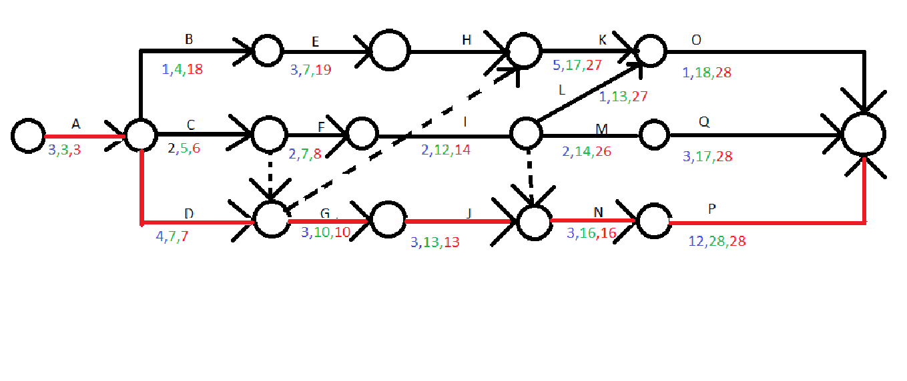

Appendix 1.1a

Appendix 1.2



Appendix 1.3 Resource Levelling for A



Appendix 1.4

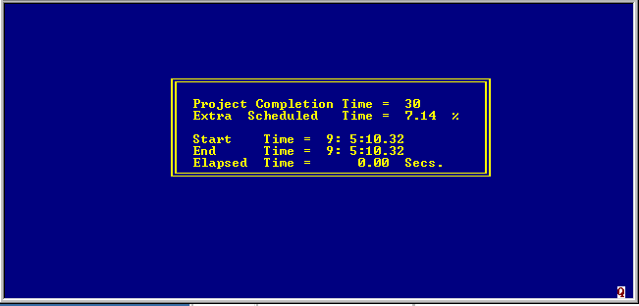

Appendix 1.5

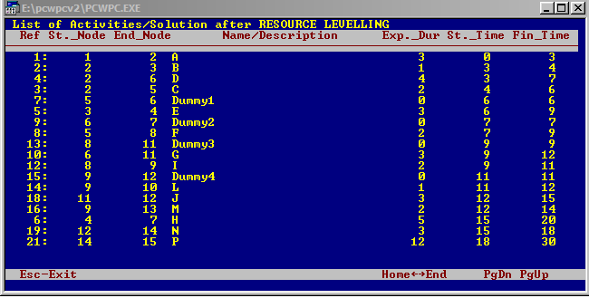

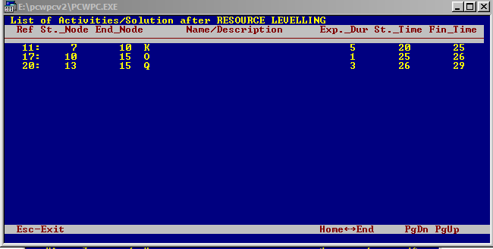

Appendix 1.6



Appendix 1.7 Staff Requirement – EST

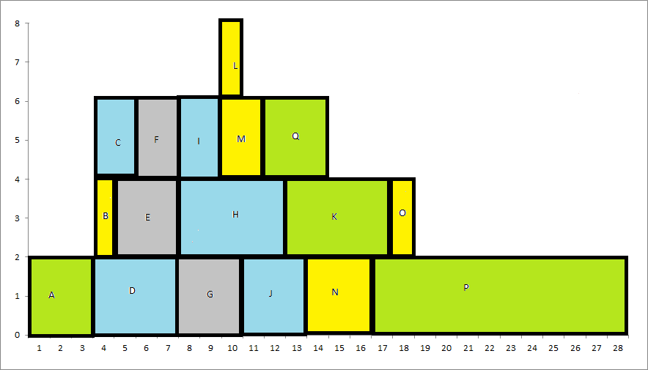

Appendix 1.8 Staff Requirement – LST

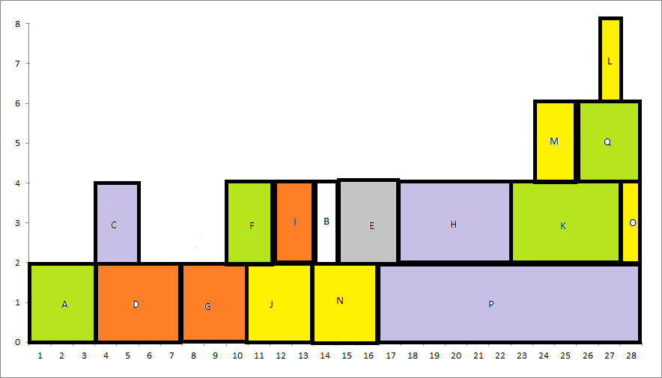

Appendix 1.9

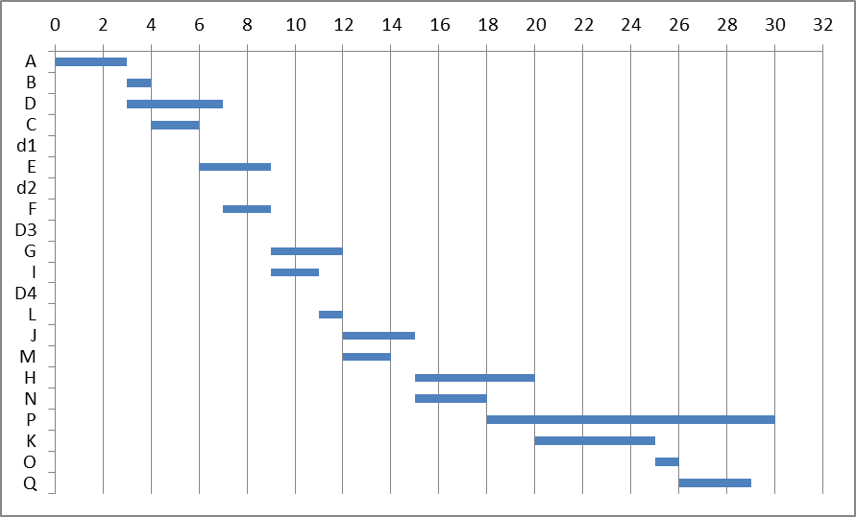

Appendix 2.1 Cumulative Resource diagram

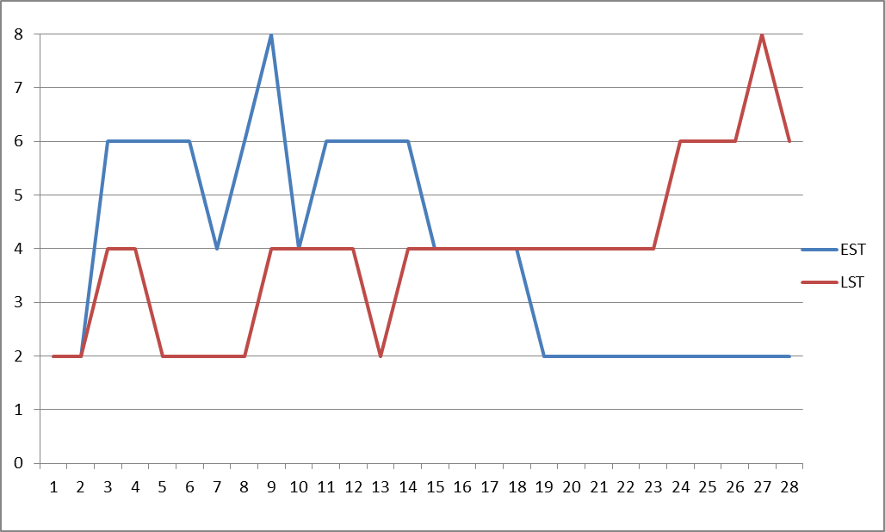

Appendix 2.2 Cumulative Requirement Curve

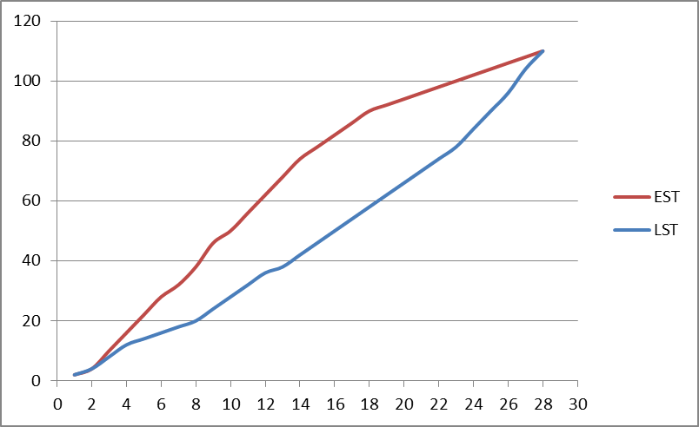

Appendix 2.3   


Appendix 2.4



Appendix 3.1

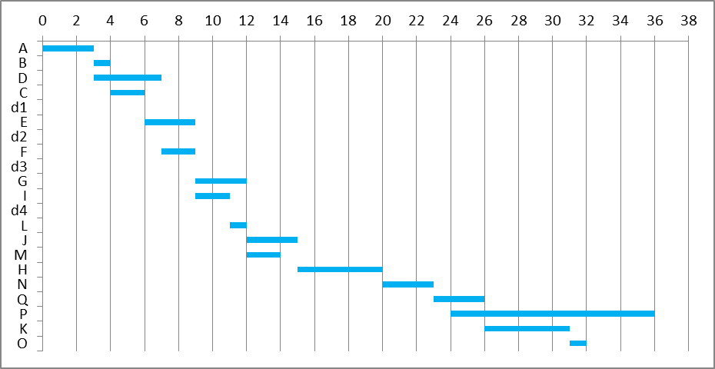

Appendix 3.2 Resource Type 1

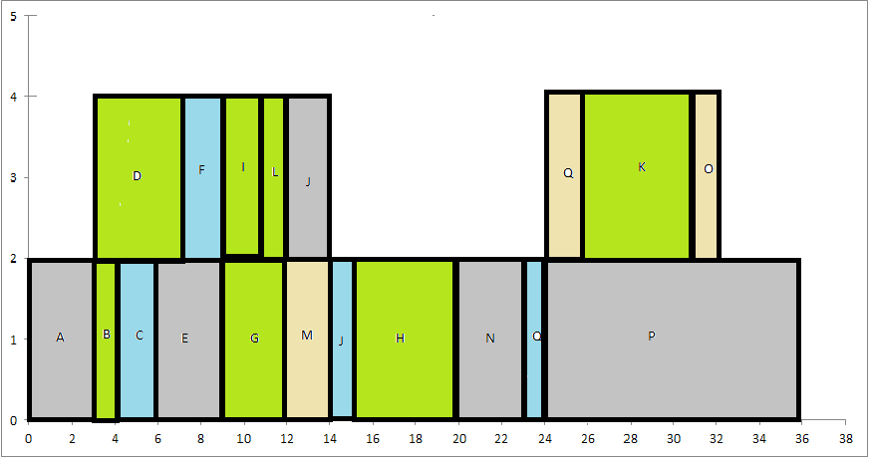

Appendix 3.3 Resource Type 2

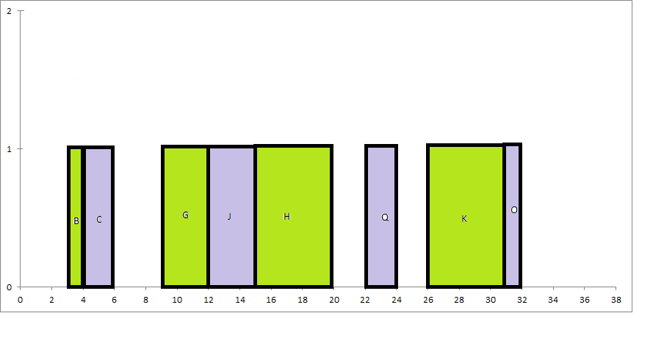

Appendix 3.4 Resource Levelling – Requirement C



Appendix 3.5

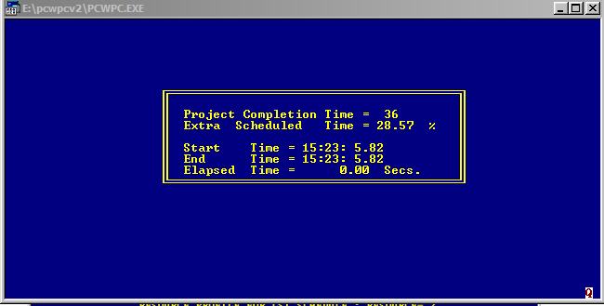

Appendix 3.6

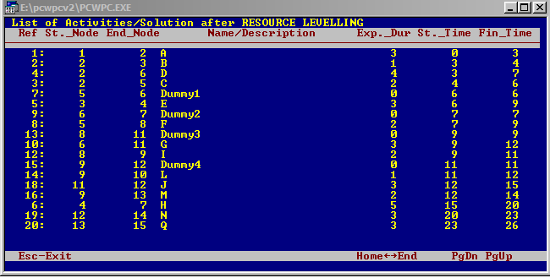

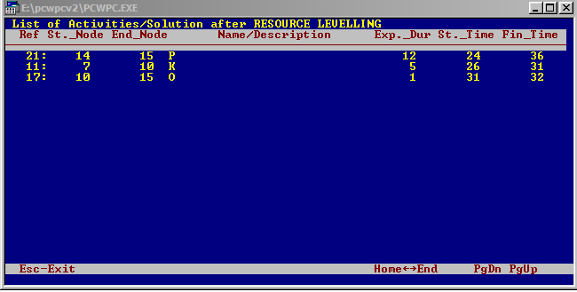

Appendix 4.1 Resource Levelling – Requirement D



Appendix 4.2

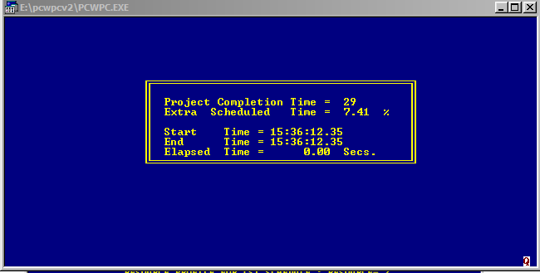

Appendix 4.3

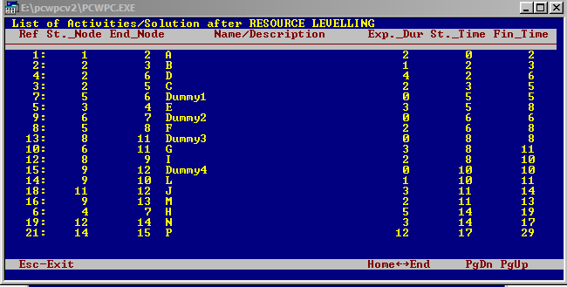

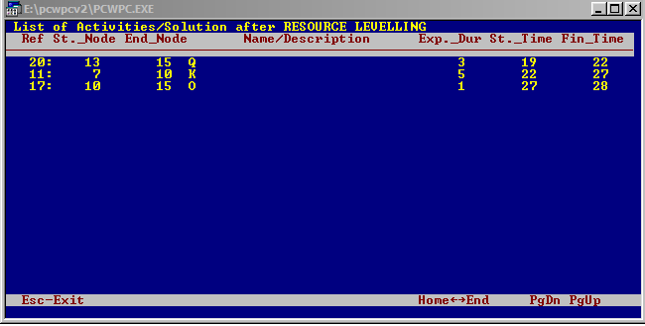

Appendix 4.4

